第一段Imagine you have a friend who’s extremely talented at music, and he challenges you to the following: you are given a musical chord, which is basically a few notes played at the same time, like this: (chord). And all you need to do is find out what the individual notes are, in this case it’s the following: (music).

第二段There’s just one issue, you know nothing about music. But, luckily for you, there’s one tool that can save you from losing this challenge: the Fourier Transform (letters).

第三段Essentially, sound is passed through vibrating air molecules. The first set of air molecules pass on their vibration to the next, compressing and expanding the space in between in a rhythmic pattern as it reaches you ear.

第四段 For instance, if we take one note and graph this change in compression over time, you can see a really nice oscillating pattern.

第五段Ok, now, the frequency is what we need to focus the most on because that differentiates our notes. It is a measure of how fast waves are oscillating, and determines the unique pitch for sound waves.

第六段If we increase the frequency, making air molecules around us vibrate faster, the pitch gets higher.

第七段For one note there’s just one frequency, and we can identify it easily on the graph. But our friend challenged us to many notes combined, and if we take the sum of say five notes, the resulting air pressure graph will look much more complicated.

第八段That’s where the Fourier transform comes in. The basic idea is that pretty much all functions can be *dissected* into simple sinusoidal waves, whether it’s our pressure curve (pressure curve) or a seemingly random curve like me speaking (speaking curve). And by applying this strangely looking mathematical formula, we can get back a frequency distribution of the simple sine curves that composed the original curve.

第九段 This is the frequency distribution for your friend’s chord. Identifying the spikes allow us to see the major contributing frequencies. Remember, the frequencies refer to the notes, so now we know all our notes.

第十段The Fourier transform is perhaps one of the most common tools embedded in modern technologies. Dissecting functions into its frequency components also allows us to store images and videos, process signals sent to your cellphones, and even scan your heart’s rhythm. But after all this mess, you can now confidently say that you’re able to identify your friend’s chords.

第一段（个人演讲视频+ 画中画？）：想象一下，你有一个在音乐方面非常有天赋的朋友，他向你提出以下挑战：给你一个音乐和弦，基本上是同时演奏几个音符，就像这样：（音轨：加一段和弦音）。你所需要做的就是找出单个音符是什么，在这种情况下是以下音符：（音轨：加一段音乐）。

Jazz Piano Chords - The Most Beautiful Progression.mp4

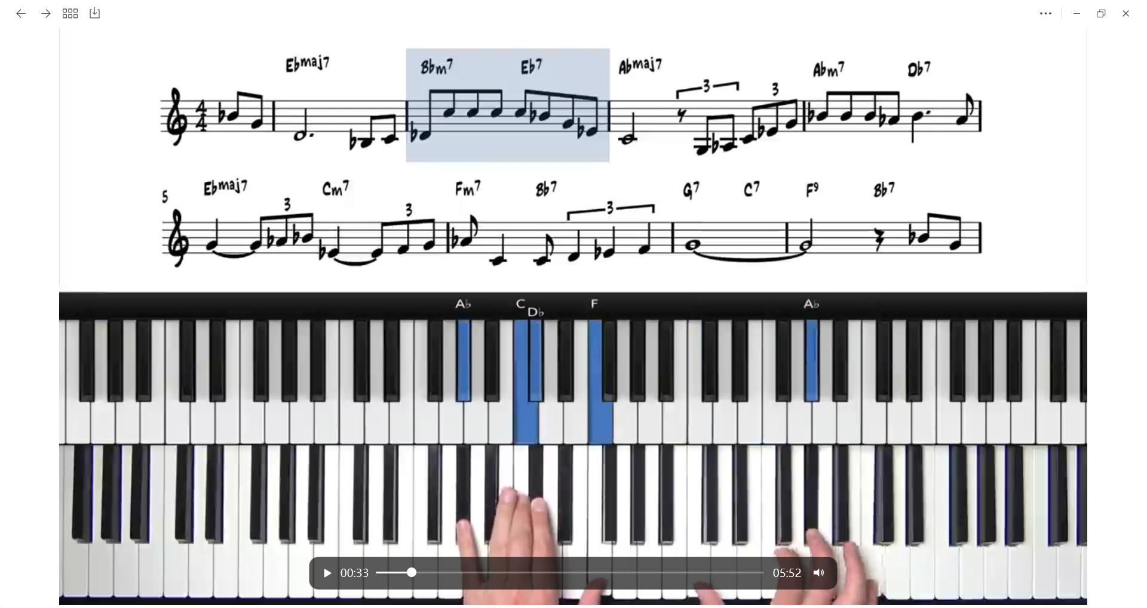

<https://www.bilibili.com/video/BV1Xh411n7mm/?spm_id_from=333.337.search-card.all.click>

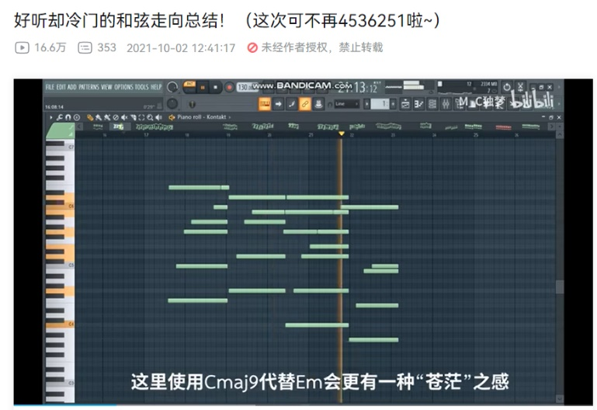

第二段（个人视频 + 显示the Fourier Transform英文字母 ）：只有一个问题，你对音乐一无所知。但是，幸运的是，有一个工具可以避免你失去这一挑战：傅立叶变换（字母）。

第三段（mp4剪辑 + 音轨：个人演讲录音）：从本质上讲，声音是通过振动的空气分子传递的。第一组空气分子将它们的振动传递给下一组，当它们到达你的耳朵时，以有节奏的模式压缩和扩大它们之间的空间。

1. Loudness, volume, level, amplitude, gain, drive - Is there a difference_.mp4

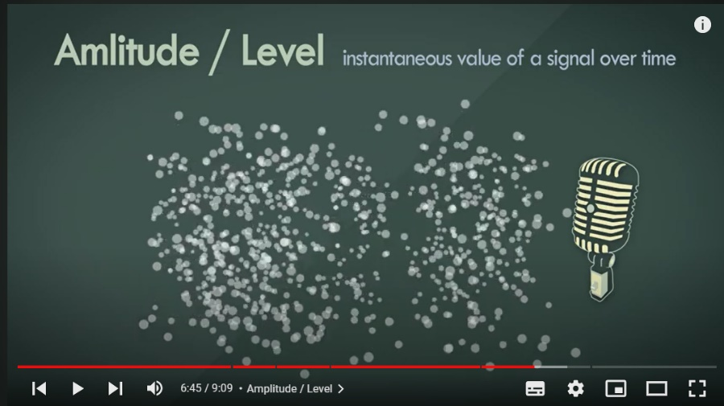

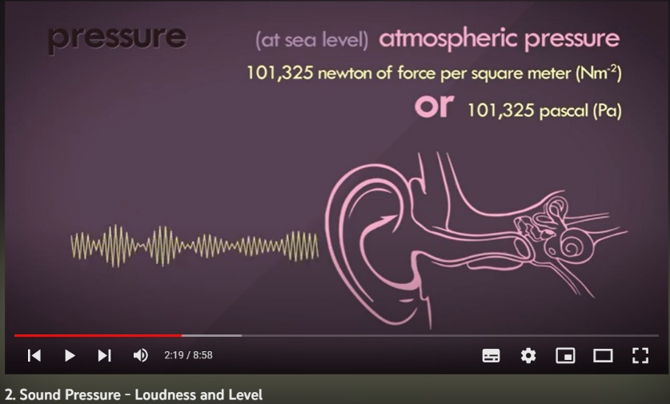

第四段（mp4剪辑 + 个人演讲录音）：例如，如果我们记下压缩随时间的变化，你可以看到一个非常好的振荡模式。

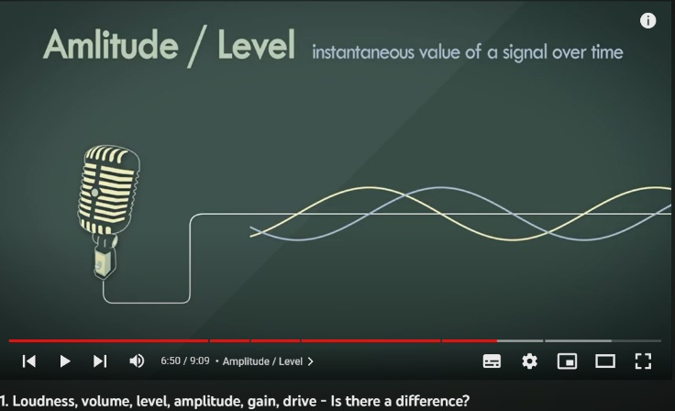

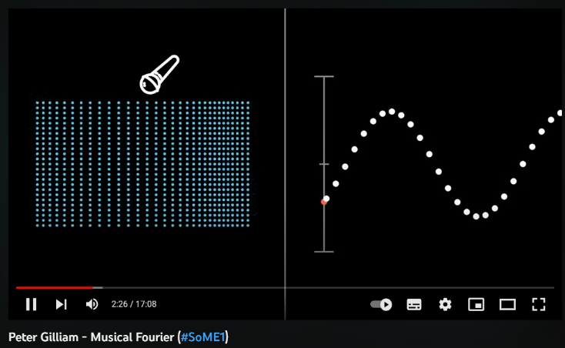

第五段（个人演讲视频）：好的，现在，频率是我们最需要关注的，因为它区分了我们的音符。它是衡量声波振荡速度的指标，并决定声波的独特音高。

<https://zhidao.baidu.com/question/571785118.html>

|  |
| --- |
| A：440Hz a:880Hz al:1760Hz  B：493.88Hz b:987.76Hz  C∶523.25Hz c:1046.50Hz 1  D: 587.33Hz d:1174.66Hz 2  E∶659.25Hz e:1318.51Hz 3  F∶698.46Hz f:1396.92Hz 4  G∶783.99Hz g:1567.98Hz 5 |

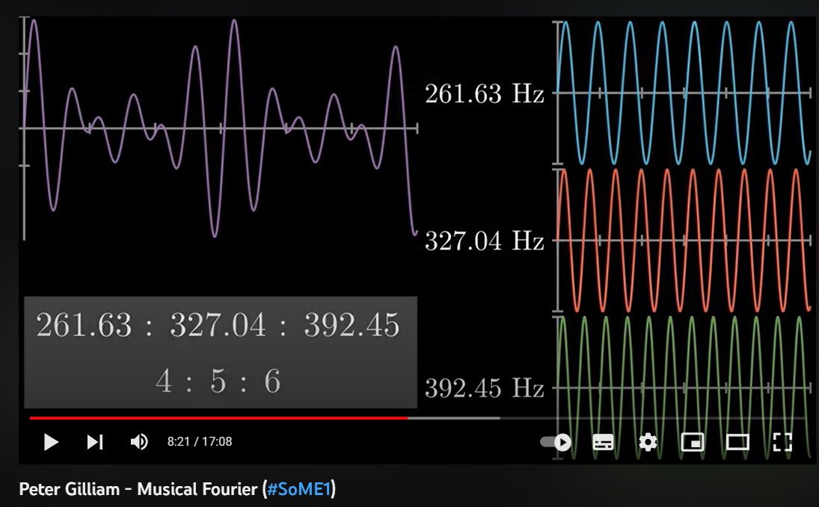

第六段：如果我们提高频率，使我们周围的空气分子振动得更快，音高就会更高。

第七段：需要注意的是，只有一个频率，我们可以在图上很容易地识别它。但我们的朋友向我们挑战了许多音符的组合，如果我们将五个音符相加，得到的气压图看起来会复杂得多。

第八段：这就是傅立叶变换的作用所在。基本思想是，几乎所有的函数都可以分解成简单的正弦波，无论是我们的压力曲线（压力曲线）还是像我说的那样看似随机的曲线（说话曲线）。通过应用这个奇怪的数学公式，我们可以得到组成原始曲线的简单正弦曲线的频率分布。

第九段：这是你朋友和弦的频率分布。识别尖峰使我们能够看到主要的贡献频率。记住，频率指的是音符，所以现在我们知道了我们所有的音符。

第十段（个人视频）：傅立叶变换也许是现代技术中最常见的工具之一。将功能分解到其频率分量中还可以让我们存储图像和视频，处理发送到手机的信号，甚至扫描你的心律。但在经历了这么多混乱之后，你现在可以自信地说，你能够识别你朋友的和弦了。